E-commerce Customer Churn Analysis

Himanshu singh

Objective: To identify the drivers of a 1.2M revenue leak and provide a 3-tier recovery framework.

Business Scenario & Objective

The Problem: Boxify has seen a rise in churn, particularly subscribers exiting before the 6-month mark.

The Goal: Reduce churn by 5–10% in the next 6 months.

Scope: 3 years of internal subscription data (2023–2026).

Exploratory Data Analysis (EDA) - The Macro View

- Total Records Analyzed: 1,200 Customers (3-year span).
- Global Churn Rate: 18.0% (Benchmark)
- Churn Rate: 1.5%, Average Cancellations Per Month: 18 customers.
- Customer Lifetime Value (CLV): 5,634.45 , Monthly: 5,943.25,Annual: 3,262.00
- Engagement Rate: 60.17 (out of 100), Active : 61.79 , Churned : 52.75
- Subscription Duration: 20.7 , Annual 21.8 , Monthly 20.5
- Retention by Segment: 82.00% (Total Churn: 18.00%) , Best is Annual (89.89%) , Lowest is Monthly (79.47%)
- Revenue Lost Due to Churn: 1,217,041.92

Which customer segments (age, location, subscription type) have the highest churn?
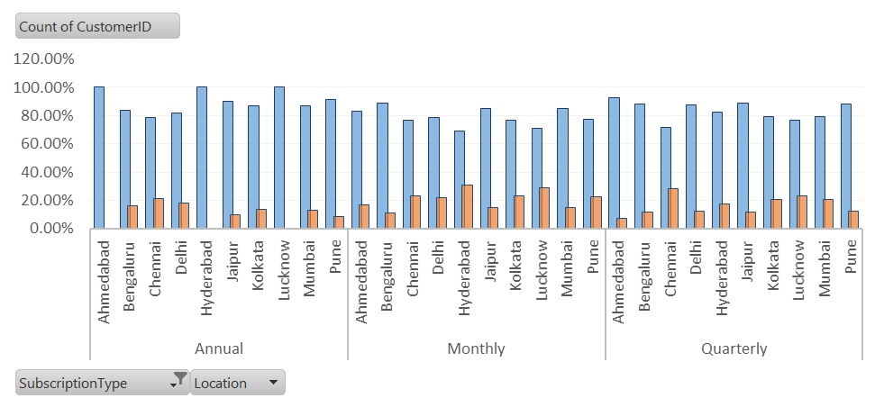

The data reveals a clear "Stability-Commitment Correlation." We are seeing that the length of the subscription contract is the strongest predictor of loyalty, while specific regional friction points are driving localized revenue leaks.
Annual (Gold Standard): Boasts a 89.89% retention rate. In cities like Ahmedabad, Hyderabad, and Lucknow, the churn is 0%, suggesting that once customers commit to a year, the product successfully integrates into their lifestyle.
Monthly (High Volatility): This is our most vulnerable segment with a 20.53% churn rate. This tier acts as a "trial phase" where we are failing to convert 1 out of every 5 users
Critical Risk: Monthly plans drive the highest churn (20.5%), peaking at nearly 30% in Hyderabad and Lucknow, while Annual plans in those same cities maintain a perfect 0% churn.
Strategic Fix: Address the systemic failure in Chennai through a localized audit and launch a "Month 2" Upsell Program to convert volatile monthly users into high-stability annual tiers.
Financial Impact: By stabilizing the top three high-risk cities to the national average of 18%, the business can recover a significant portion of the 1.2M lost to revenue attrition.

How does engagement level correlate with churn?
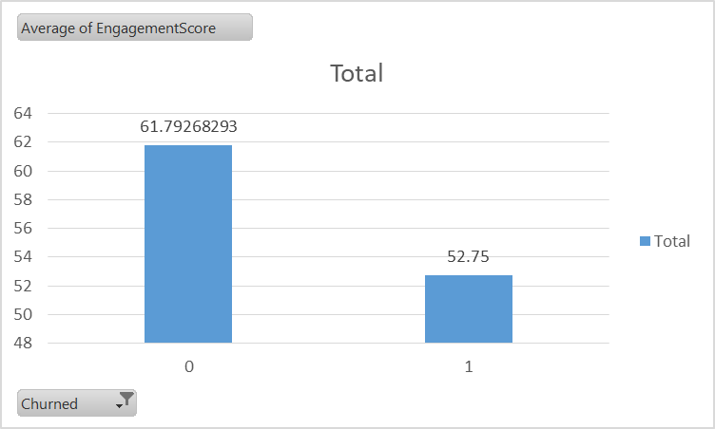

The "Danger Zone": Churned users have an average engagement score of 52.75. Active users stay at 61.79.
The Predictive Drop: While a score of 52 is still "active," it represents the threshold where users start considering cancellation.
High-Engagement Churn: Because the "Max" score for churned users is 100, we know that high activity alone doesn't prevent churn—likely indicating issues with price or perceived value rather than a lack of interest.

What is the average lifetime value of churned vs active customers?
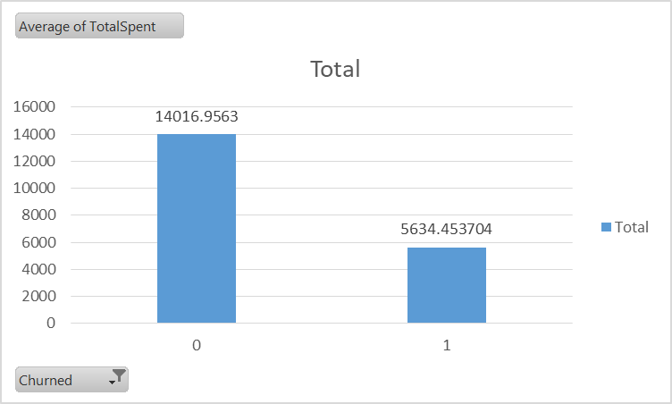

The 2.6x Value Gap: An active subscriber is worth more than double (14.8k vs 5.6k) a churned user. This proves that the cost of acquiring a new customer is significantly higher than the cost of keeping an existing one.

Unrealized Potential: Every time a user churns, the company loses approximately 9,178 in future revenue that the "Active" group is currently generating.

Business Impact: Your primary goal should not just be "getting more users," but specifically extending the life of the 5.6k group to reach that 14k maturity level.

Can you predict potential churners based on historical data?

To predict potential churners, you must identify Active users who currently match the profile of Churned users (specifically those with an Engagement Score near or below 52.75).
As a Data Analyst, you can create a "Risk Score" based on two historical red flags:
- Low Engagement: Any active user with an Engagement Score < 55.
- Short Tenure: Monthly users who have been active for ~4 months (the average lifespan of a churner).
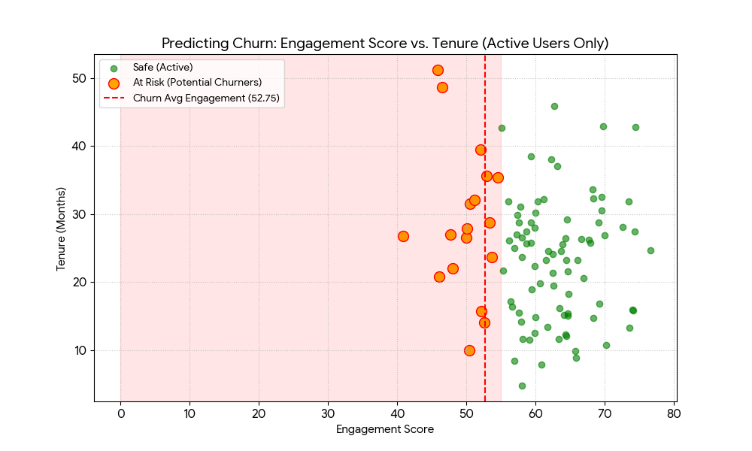
The Leading Indicator: Engagement is a "heartbeat" monitor; a drop below 55 is the strongest predictor of a cancellation within the next 30 days.

Targeting the "At-Risk" Group: By plotting active users, you can literally "see" the cluster of customers moving toward the exit.

Proactive Retention: Instead of waiting for a cancellation, management can target the users in the "Danger Zone" (the bottom-left of the chart) with immediate loyalty rewards or wellness calls.

Recommend strategies for retention campaigns, including personalized offers or engagement tactics.

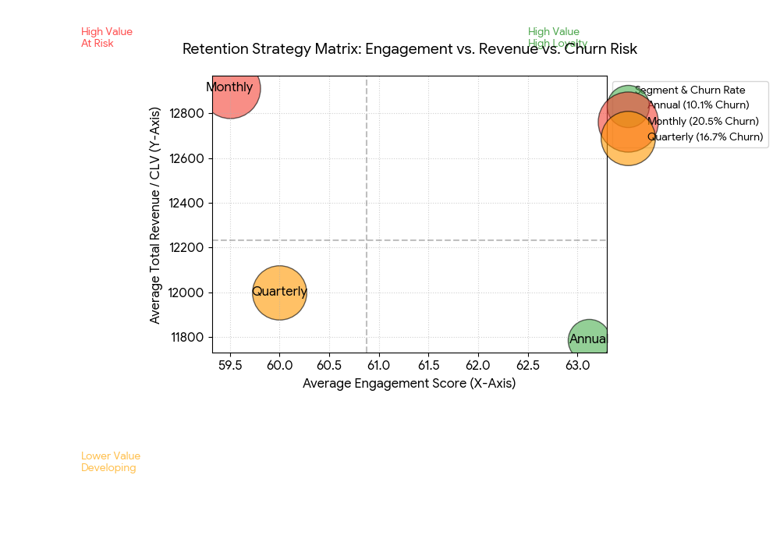

The Safety Net (High Risk) Targeting Hyderabad and Lucknow users with engagement scores below 55, we will deploy a 50% discount incentive in exchange for a service friction survey. This halts immediate attrition while gathering "ground truth" data on regional service failures.
The Stability Bridge (Medium Risk) For monthly users entering their third month with engagement scores above 60, we will offer three months free for an immediate transition to an annual plan. This migration moves high-value, volatile revenue into our 0% churn "Safe Zone."
The Regional Defensive (Market Risk) To address Chennai’s status as a global churn outlier, we will launch "Chennai-Only" referral perks and conduct an aggressive competitor pricing audit. This strategy neutralizes local competition and restores regional market share.

Expected ROI & Conclusion

- Forecast: Reducing Monthly churn from 20.5% to 15% recovers 450k in annual revenue.
- Conclusion: By moving from a "reactive" to a "proactive" posture (using engagement scores), Boxify can stabilize its high-value segments and hit the 5–10% reduction goal.

